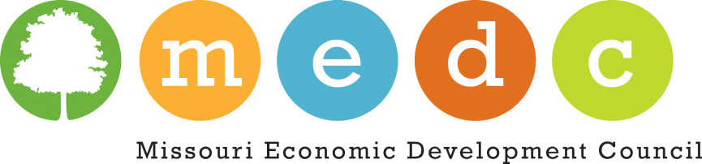
2015 FALL CONFERENCE INFORMATION
SCHEDULE
The conference schedule will be loaded in the near future. An email will be sent out to all members to alert. Conference will begin at 1 p.m. on Wednesday, October 21, 2015 and end at noon on Friday, October 23, 2015.

HOTEL INFORMATION:
For hotel reservations contact:
Courtyard by Marriott Hotel
3301 LeMone Industrial Boulevard, Columbia, MO 65201
573-443-8000
A block of rooms has been reserved for MEDC at Courtyard by Marriott Columbia with room rates of $109.00+. Please identify that you are calling to reserve a room in the MEDC block. This room block will be released on September 22, 2015. Room availability or pricing cannot be guaranteed after that date.

SPECIAL INFORMATION:
No-shows are responsible for payment of registration.
No refunds after October 6, 2015.
Attire is Business Casual for the conference.

QUESTIONS OR SPECIAL NEEDS?
Contact MEDC – Pat Amick, CMP – (573) 636-7383 or email to pat-amick@showme.org

50/50 RAFFLE:
Again at this conference, we will be selling 50/50 raffle tickets. Funds will benefit the MEDC Scholarship Account.

EXHIBITORS:
No exhibit space provided at this conference.

SILENT AUCTION:
No Silent Auction at this conference.

